

**National College of Ireland**

**Project Submission Sheet – 2017/2018**

**School of Computing**

|  |  |  |  |
| --- | --- | --- | --- |
| **Student Name:** | Daniel Costel Neagu | | |
| **Student ID:** | X17128463 | | |
| **Programme:** | BSHCE15 | **Year:** | 1 |
| **Module:** | Software Applications for Business | | |
| **Lecturer:** | Josephine Andrews | | |
| **Submission Due Date:** | 21/04/2018 | | |
| **Project Title:** | Individual Report – Derek’s CRM Report for MCTV-Limited + User Guide | | |
| **Word Count:** | 2150 | | |

**I hereby certify that the information contained in this (my submission) is information pertaining to research I conducted for this project. All information other than my own contribution will be fully referenced and listed in the relevant bibliography section at the rear of the project.**

**ALL internet material must be referenced in the bibliography section. Students are encouraged to use the Harvard Referencing Standard supplied by the Library. To use other author's written or electronic work is illegal (plagiarism) and may result in disciplinary action. Students may be required to undergo a viva (oral examination) if there is suspicion about the validity of their submitted work.**

|  |  |
| --- | --- |
| **Signature:** | Daniel C. Neagu |
| **Date:** | 19/04/2018 |

**PLEASE READ THE FOLLOWING INSTRUCTIONS:**

1. Please attach a completed copy of this sheet to each project (including multiple copies).

2. **You must ensure that you retain a HARD COPY of ALL projects**, both for your own reference and in case a project is lost or mislaid. It is not sufficient to keep a copy on computer.

|  |  |
| --- | --- |
| **Office Use Only** | |
| Signature: |  |
| Date: |  |
| Penalty Applied (if applicable): |  |

Derek’s CRM Report for MCTV-Limited

Contents

a} Advantages and challenges. 3

b) The cost and benefits of this solution. 3

Microsoft Dynamics 365 Pricing Plans: 3

Enterprise Edition 3

Business Edition 4

c) 3 other CRM alternative packages. 4

d) Training, introductory guide for Dynamics software. 5

1. Sign in to Dynamics 365: 6

2. Quick create – Enter new records: 7

3. Set up a product catalogue: 7

3. Create or edit a lead: 8

5. Create or edit a quote: 9

6. Create or edit an order: 10

e) Why should we choose this project ahead? 11

References: 12

# a} Advantages and challenges.

Customer relationship management (CRM) is an approach to manage a company's interaction with current and potential customers. It uses data analysis about customers' history with a company to improve business relationships with customers, specifically focusing on customer retention and ultimately driving sales growth.

One important aspect of the CRM approach is the systems of CRM that compile data from a range of different communication channels, including a company's website, telephone, email, live chat, marketing materials, and more recently, social media. Through the CRM approach and the systems used to facilitate it, businesses learn more about their target audiences and how to best cater to their needs.

With CRM, the company owns the single best tool for customer success—accurate information.

# b) The cost and benefits of this solution.

The CRM market is about to reach a whopping $36 billion in 2017, which is a brave but also reasonable forecast considering the benefits often associated with this system. Experts believe that investing in a quality CRM product is more important than ever, as tools that boost sales productivity by as much as 27% are becoming strikingly inexpensive.

## Microsoft Dynamics 365 Pricing Plans:

### Enterprise Edition

* Dynamics 365 Plan: From $210 per user/month.
* Get full use of all applications in one comprehensive, cost-efficient option.
* Unified Operations Plan: From $190 per user/month.
* Get full use of applications that help connect and manage your business operations.
* Customer Engagement Plan: $115 per user/month.
* Get full use of applications that help build and support customer relationships.
* Applications and offers: From $40 to $170 per user/month.
* Start with what you need, then upgrade to plans as your business grows.

### Business Edition

* Full User: From $40 per user/month.
* Get full access to application functionality.
* Team Members: From $5 per user/month.
* Execute basic processes and light tasks.
* External accountant license: Free with full user.
* Access the service at no additional cost.

With CRM systems customers are served better on a day to day process and with more reliable information their demand for self-service from companies will decrease. If there is less needed to interact with the company for different problems, customer satisfaction level increases. These central benefits of CRM will be connected hypothetically to the three kinds of equity that are: relationship, value and brand, and in the end to customer equity. Eight benefits were recognized to provide value drivers:

1. Enhanced ability to target profitable customers,
2. Integrated assistance across channels,
3. Enhanced sales force efficiency and effectiveness,
4. Improved pricing,
5. Customized products and services,
6. Improved customer service efficiency and effectiveness,
7. Individualized marketing messages also called campaigns,

Connect customers and all channels on a single platform.

# c) 3 other CRM alternative packages.

I have investigated four CRM packages that are direct competitors now on the market, which Microsoft Dynamics would be a worthwhile investment for the €100,000 as they already had Microsoft Office and this CRM package would facilitate strengthening customer relationships. Three other alternative packages investigated that are direct competitors to Microsoft Dynamics were Infusionsoft, Salesforce and Oracle.

First company provider of CRM packages investigated as a direct competitor to Microsoft Dynamics for this project was Infusionsoft. Is a cloud-based sales and marketing solution that offers CRM, Marketing Automation and E-Commerce functionalities in one suite that helps small businesses across various industries deliver sales volumes and customer service experiences. Users can segment their contacts, track customer interactions, send emails, run campaigns setting triggers for personalized communications based on email opens, clicks and more. Users can also manage their e-commerce, from inventory management to payments and purchase fulfilment, set up online shopping carts, track activity in their digital storefront, send quotes, invoices and receipts.

A second CRM provider investigated was Salesforce, which provides companies with an interface for case management and task management, and a system for automatically routing and escalating important events. The Salesforce customer portal provides customers with the ability to track their own cases, includes a social networking plug-in that enables the user to join the conversation about their company on social networking websites, provides analytical tools and other services including email alert, Google search, and access to customers' entitlement and contracts.

The third company of CRM packages provider was Oracle. Oracle's integrated Customer Relationship Management (CRM) solution is a set of applications that give you information-driven sales, service, and marketing. Oracle CRM is built on an open, standards-based architecture that streamlines business processes, improves data quality, and allows all your key divisions to draw from the same source of data.

Microsoft Dynamics is the winner of all these CRM providers because works seamlessly with Microsoft Outlook and Microsoft Office productivity tools already owned by the MCTV company, so staff do not have to learn new applications and can be instantly productive. Microsoft Dynamics is going places and those places are being mapped out to meet user needs. Dynamics 365 (like Office 365) signals the direction Microsoft is taking their CRM.

Basically, they are positioning themselves to make CRM accessible, user-friendly, and subscription-based but affordable. Dynamics 365 has been newly released and it packages together the many apps that comprise the Dynamics CRM suite, together with new applications such as the intelligent analytics of Customer Insights, which uses Microsoft’s artificial intelligence to drill down into your customer behaviours to see trends and predict outcomes.

While Infusionsoft, Salesforce and Oracle offer much of the same functionality as Dynamics, and while are representing a solid option for CRM, there are many reasons to ultimately go with Dynamics. Mainly, Dynamics will save you money, will hold out for the long term, and will give you access to all the benefits that come from going with Microsoft on this one.

# d) Training, introductory guide for Dynamics software.

Dynamics 365 for Sales enables salespeople to build strong relationships with their customers, take actions based on insights, and close sales faster. Use Dynamics 365 for Sales to keep track of your accounts and contacts, nurture your sales from lead to order, create sales collateral, create marketing lists and campaigns and even follow service cases associated with specific accounts or opportunities. Available anywhere, on any device.

## 1. Sign in to Dynamics 365:

1. Select the Office 365 app launcher,
2. Then select the icon for Dynamics 365.

The following image shows the menu for Dynamics 365 the Sales app.

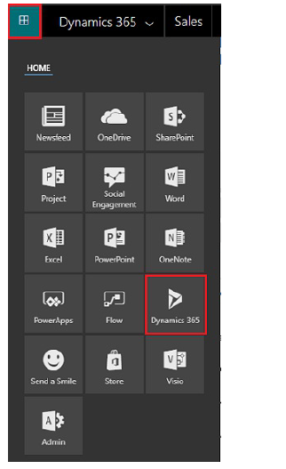

Understand the data in the app.

Every day, you’ll work with different customer records and record types as you move customers through your business processes, collecting the data you need to fill in the fields for their records and ultimately to win their business.

* What’s a record? In Dynamics 365, a record is a complete unit of information such as all the information about a single contact. You can think of it as a row in a table. For example, each time you add a new account to the app, you’re creating a new record in the Sales app.
* What’s a record type? Each record you add to the system belongs to a certain record type, such as an account, contact, lead, or opportunity.

## 2. Quick create – Enter new records:

The Quick Create command makes it fast and easy to enter almost any type of information into the system. The command is on the navigation bar (also referred to as the nav bar).

You can quickly create:

1. Contacts
2. Accounts
3. Leads
4. Opportunities
5. Campaign responses
6. Competitors
7. Activities: tasks, phone calls, email, or appointments.

So, it’s always available whenever you need to enter new info into the system in 2 steps:

1. On the nav bar, select the New button, and then select the item you want.
2. Fill in the fields, and then select Save.

With Quick Create, you need to complete only a few fields. Later, when you have more time or more information, you can fill in more details.

## 3. Set up a product catalogue:

The product catalogue is a collection of products and their pricing information. To set up pricing, you need to define the units in which your products are sold, the amount to charge for each unit, and the discounts you want to offer based on volume purchased. Other than setting up the pricing for products, product catalogue also supports product taxonomy that lets you create a rich classification of products. This helps ensure that your customers receive the most appropriate and complete solution: 1. Go to Settings > Product Catalogue. 2. In the Product Catalogue area, click Products. 3. To create a product, click Product. 4. Fill in your information. Use the handy tooltips as a guide.

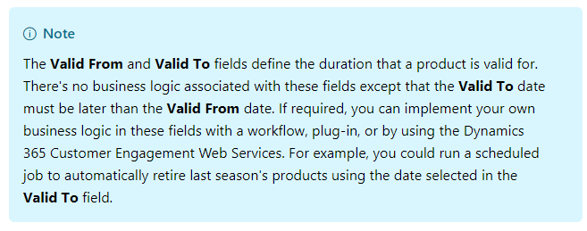

6. Click Save. 7. In the list of products and bundles, open the Product that you just created. 8. In the Product Properties section, click the Add Properties Button Add properties button, and add the required properties.

More information: Use properties to describe a product.

## 3. Create or edit a lead:

In the Sales app, you use leads to keep track of business prospects that you haven't yet qualified through your sales process. A lead can be an existing client or someone you've never done business before. You might get leads from different sources, such as advertising, networking, or email campaigns.

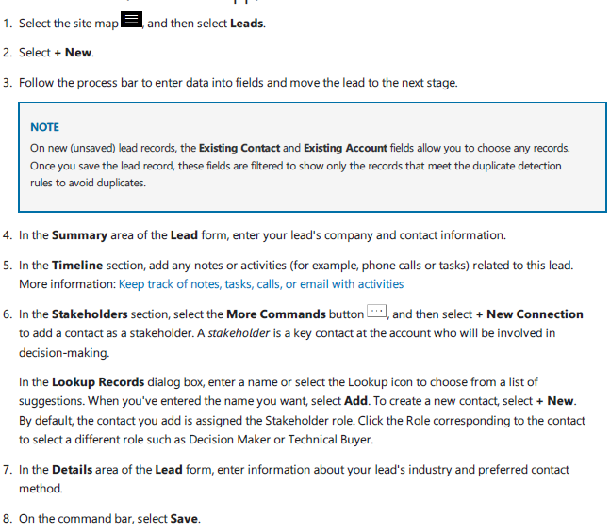

## 5. Create or edit a quote:

One way that can help you increase your sales is to add all products that your customer might need to your quote. Your Dynamics 365 system might offer product bundles or product families to make it easier for you to choose products for upselling and cross-sell.

When the customer accepts the quote, you create an order. Otherwise, you close the quote as revised, cancelled, or lost.

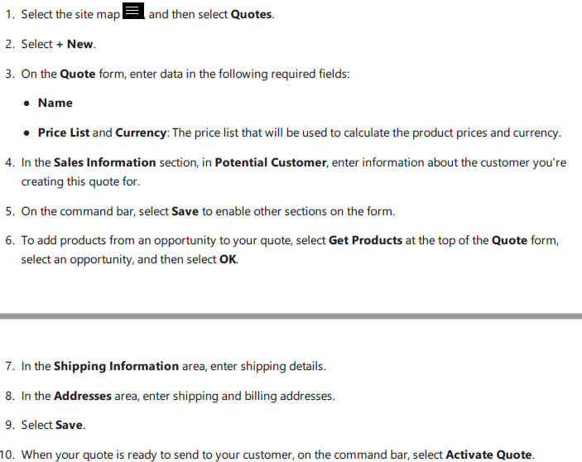

## 6. Create or edit an order:

Congratulations! Your hard work nurturing your customer has paid off and they're ready to place an order for your products or services. In Dynamics 365, an order can originate from a customer's acceptance of a quote, or you can place an order without an accepted quote, depending on the situation.

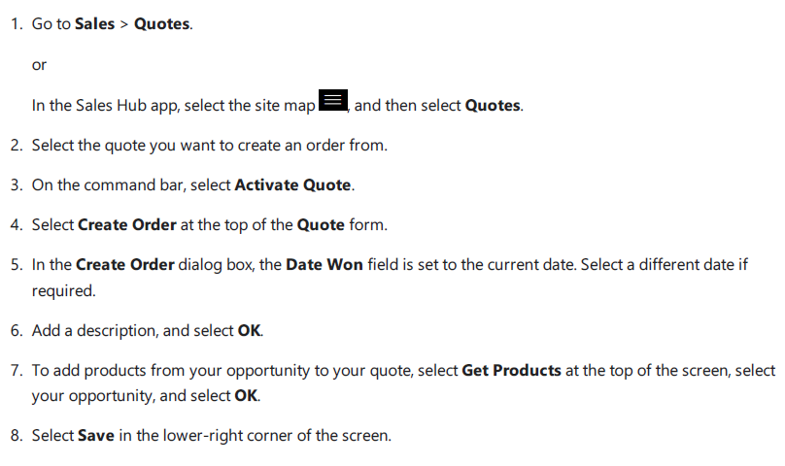

# e) Why should we choose this project ahead?

The point is that whatever you think of for your interaction with the clients can be automated with CRM system. The CRM systems are good for interacting with new customers and re-engaging with your existing customers from the past. Aside from the automation, CRM systems are also good because is a centralized environment. Microsoft Dynamics would be a worthwhile investment for the €100,000 as we already have Microsoft Office and this CRM package would facilitate strengthening customer relationships, that boost sales productivity by as much as 27% a year and is becoming strikingly inexpensive.

# References:

En.wikipedia.org (2018).*Customer relationship management.[*online] Available at: <https://en.wikipedia.org/wiki/Customer_relationship_management#cite_note-1> Accessed:[2018].

Dynamics.microsoft.com (2018). *Microsoft Dynamics 365: Intelligent Business Applications.* [online] Available at: <https://dynamics.microsoft.com/en-ie/> Accessed:[2018].

Oracle.com (2018). *CRM Software - Customer Relationship Management | Oracle.* [online] Available at: <https://www.oracle.com/applications/customer-experience/crm/index.html> Accessed:[2018].

Salesforce.com (2018). *Small-business-solutions* [online]Available at: <https://www.salesforce.com/uk/solutions/small-business-solutions/essentials/> Accessed:[2018].

Infusionsoft.com (2018). *Small Business CRM Software | Infusionsoft.* [online] Available at: <https://www.infusionsoft.com/product/features/small-business-crm> Accessed:[2018].